An Intelligent College Placement Prediction and Skill Gap Recommendation System Using Machine Learning
Dr.V.V.A.S.Lakshmi Professor
CSE(Data Science)
Narasaraopeta Engineering College
Narasaraopet,India
vvaslakshmi@nrtec.in
Eedumalli Swetha
Student
CSE(Data Science)
Narasaraopeta Engineering College
Narasaraopet,India
23471A4413@nrtec.in
Prudhivi Nikhil Kumar
Student
Cse(Data Science)
Narasaraopeta engineering college
Narasaraopeta,india
24475A4407@nrtec.in
Shaik Mohammed Gani
Student
Cse(Data Science)
Narasaraopeta engineering college
Narasaraopeta,india
23471A4452@nrtec.in
Abstract
Campus placements aren’t just some formality—they shape a student’s future, and let’s be real, they’re a big deal for a college’s image too. The problem is, most students have no clue if they’re actually set for placements. They’re unsure about their weak spots, and half the time, they don’t even know which companies they can apply to. Traditional placement checks? Slow, a bit too subjective, and honestly, not all that helpful. That’s where this project steps in. We’re talking about an Intelligent College Placement Prediction and Skill Gap Recommendation System powered by Machine Learning. It doesn’t miss a thing—grades, aptitude, technical and communication skills, internships, projects, certifications, mock test scores, all of it. It uses a Random Forest classifier, which just works—it’s both accurate and consistent. But there’s more. It’s not just about predicting if you’ll get placed. The system digs deeper. It pinpoints where you’re falling short, lets you try out different “what if” scenarios, and matches you with companies you actually qualify for. Students get a clear picture: if you level up one skill, like your technical knowledge, you can see exactly how much your chances improve. In early trials, the system nailed placement predictions and gave quick feedback, so it fits right into the college environment.

Keywords
College placement prediction, skill gap analysis, machine learning, Random Forest classifier, career recommendation system.
introduction
Campus placements pretty much shape what happens next for students about to graduate. For colleges, placement rates are everything—people judge them by those numbers. So, everyone’s under pressure to get it right. These days, recruiters don’t just care about grades. They look at your problem-solving skills, technical know-how, how well you communicate, and whether you’ve actually done anything hands-on—like internships or real projects. But honestly, most students have no idea how all of this fits together or what matters most for landing a job. The usual prep isn’t much help, either. Most colleges just run generic training sessions, a few mock interviews, and basic shortlisting. Sure, that’s better than nothing, but it doesn’t really tell students what they’re good at, what they need to work on, or if they’re actually ready to go out and get hired. Even the fancy machine learning prediction tools that exist just spit out a yes or no—no real explanation, no advice on what to fix. That’s where our project steps in. We built a smarter placement prediction system, using machine learning in a way that actually helps. Instead of just saying, “You’ll get placed” or “You won’t,” it breaks things down. The system checks out your grades, skills, internships, and more, then shows you exactly where you’re falling short—and what to do about it. The best part is the what-if analysis. You can see, right away, how improving your communication skills or picking up a new technical skill can change your odds. It even checks which companies you’re eligible for, so you know which jobs make sense to target. By putting predictions, personalized feedback, and simulations all in one place, this tool’s a game-changer for both students and placement teams. Instead of scrambling after missed chances, everyone can plan ahead, use real data, and actually close the gaps that matter to recruiters. Getting a campus placement is tough right now, so it’s more important than ever for students to know where they stand early—and what to do next. The old way—endless mock interviews, one-size-fits-all advice—just doesn’t cut it anymore. Every student’s got their own story, their own strengths and weaknesses, but traditional prep barely notices. Now that we’ve got all this data and machine learning at our fingertips, we can finally do better. Our system predicts how likely each student is to get placed, looking at real factors like academics, tech skills, projects, internships, and even what’s on their resume. It doesn’t just guess; it digs in, finds what needs work, and suggests smart, practical next steps for each person. Bottom line, this project gives students the clear, honest guidance they need to level up and plan their careers. And for colleges, it’s a straight path to improving placement stats with data that actually means something.

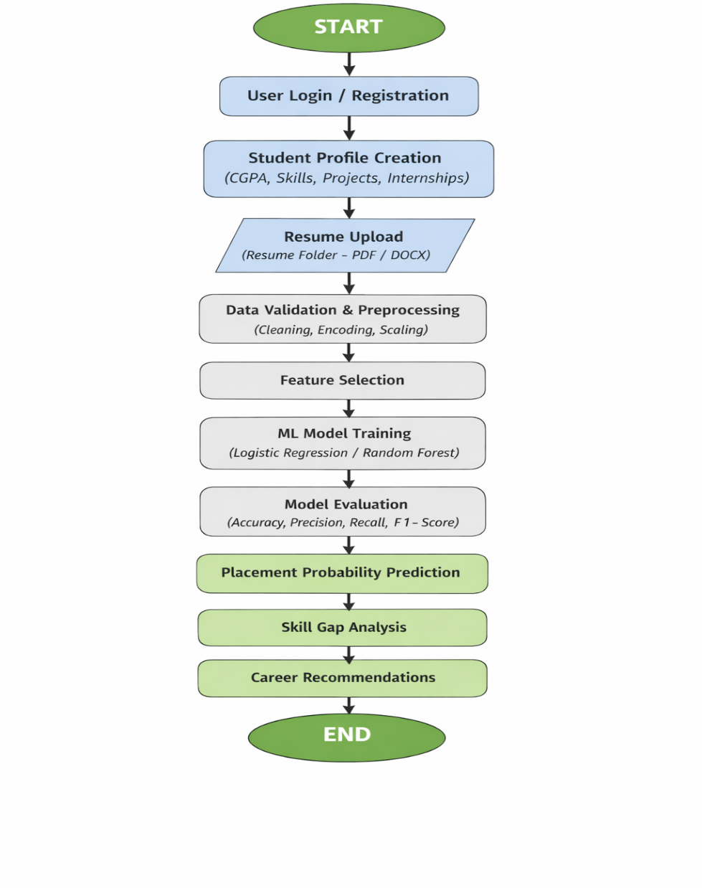
- LITERATURE SURVEY

Ahmad and the team looked at how machine learning can help predict student performance and job placement. They found that mixing academic records with skill-based info makes predictions a lot more accurate. Their work showed that algorithms like Logistic Regression and Random Forest really do well when you feed them real student data. This idea sits at the heart of our system—we use both grades and skill details to predict a student’s placement chances.[1]
Ranaweera’s group zeroed in on how important historical data is for predicting what’s next. If you pick the right data and the right features—think marks, internships, tech skills—you get much sharper predictions. That’s exactly why our system carefully selects these student features to boost placement results. [2]
Bhattacharyya and colleagues went for a hybrid approach, blending several machine learning models. Their takeaway? Hybrid models beat single algorithms when it comes to accuracy. We borrowed this strategy and use ensemble learning to sharpen our predictions and spot skill gaps.[3]
Panigrahi’s team put different regression and classification models head-to-head. Turns out, ensemble models like Random Forest and Gradient Boosting usually come out on top, no matter the dataset. This insight helped us pick the best models for predicting placement chances in our system.[4]
Thakur’s study connects digital literacy with job outcomes. Basically, students who understand their own skills and what employers want tend to do better during placements. That’s why we built a skill improvement and guidance module—to help students see where they stand and how they can boost their employability.[5]
Kumar and Shukla built a machine learning recommendation system that suggests careers based on personal skills. Their results show that tailored advice really helps people make smarter career choices. We took that cue—our system gives custom skill recommendations based on each student’s profile and their predicted placement results.[6]
Thilakarathne and team came up with a cloud-based recommendation system using machine learning for real-time predictions. They pointed out how crucial cloud deployment is for making the system accessible and reliable. We run our application on the cloud too, so it’s always available for users.[7]
Shankar’s research used machine learning to analyze all sorts of environmental and contextual data. They found that Decision Trees and Support Vector Machines do a solid job when you have lots of different input features. This backs up our decision to use tree-based models in our placement prediction system. [8]
Escorcia-Gutierrez introduced an ensemble learning model that boosts accuracy by combining multiple classifiers. They proved ensemble techniques handle complex datasets really well. We use this same idea to get steady, accurate placement predictions.[9]
Priyadharshini’s team made an intelligent recommendation system that looks at the user’s background and context. They showed that considering more factors—like academic scores, technical abilities, and soft skills—leads to better recommendations. Our system does the same, combining all these elements to give meaningful placement insights.[10]
Rajković and colleagues explored Artificial Neural Networks and Random Forests for prediction tasks. Their results? Hybrid and multi-model approaches just work better. This supports our system’s flexible design, letting us choose whichever machine learning model gets the best results. [11]
Dholu and his team showed that web-based intelligent systems aren’t just scalable—they actually make it easier for users to interact, too. They backed up the idea of building intelligent apps on a web-based setup. In their approach, they went with a Flask backend and paired it with a modern frontend, so users get a seamless experience [12].
DeChant and colleagues tackled deep learning and proved these models are great at spotting patterns in huge datasets. Their results make it clear: advanced models boost prediction accuracy. It’s exciting because it means the proposed system can get even better if you add deep learning down the line [13].
Johannes and team built mobile and web apps that let people interact with prediction systems without any hassle. They really drove home how crucial it is to have user-friendly interfaces. That’s why the proposed system puts a lot of effort into a clean, modern UI to make placement results easy to read and understand [14].
Rajak and colleagues pointed out that decision support systems powered by machine learning actually help people make smarter choices. Their research backs up how intelligent systems can improve decision-making. The proposed system takes this to heart, giving students data-driven insights so they can make smarter career moves [15].
Balamurali and his team dived into how intelligent systems share data. They focused on making data transfer between different components efficient. You can see this in the proposed system’s design, where the frontend, backend, and database all communicate smoothly [16].
Sonobe and colleagues put Random Forest classification to the test on big, complicated datasets and proved it works well. Their results make a strong case for using Random Forest in the placement prediction model [17].
Palagin’s group explored how intelligent data acquisition systems affect prediction accuracy. They showed that having well-structured datasets is key for training models that you can rely on. The proposed system uses this approach to boost its reliability [18].
Oerke and Dehne talked about how early predictions and timely advice can make a real difference in decision support systems. Their work proves that early guidance improves outcomes in the end. That’s exactly what the proposed system does: it predicts placement chances early on and suggests ways to build up the right skills [19].

PROPOSED METHODOLOGY
Dataset Description
The Student Placement Prediction Dataset brings together real student records straight from college academic and placement cells. It’s built to reflect real-life placement situations, with details that cover academic history, technical skills, and even behavior—basically, everything that can tip the scales when it comes to getting hired. Every entry in this dataset stands for one student, with a mix of features (think: grades, projects, soft skills) and a target label that simply says if the student got placed or not. The dataset has somewhere between 2,000 and 3,000 students. That’s enough data for solid machine learning experiments and, importantly, both placed and not placed students are represented pretty evenly. Academic attributes take up a big chunk of the data, since recruiters almost always look at grades first. There’s CGPA, 10th and 12th grade marks, backlog counts, and attendance rates. Together, these paint a picture of a student’s consistency and academic discipline. But grades aren’t everything. The dataset also tracks technical skills. It notes which programming languages students know (like Python, Java, or C++), what certifications they’ve picked up, how many projects they’ve done—both for class and on their own—and whether they’ve had any internships or industry training. These details show how ready a student is to jump into a real job. Employers also care about soft skills and aptitude, so those are here too. You’ll find aptitude test scores, logical reasoning results, communication ratings, and signs of teamwork or leadership. These help the model see the whole person, not just their report card. The data itself is a mix of numbers and categories. Things like CGPA and test scores are continuous values, while attributes like department, gender, or internship status are categorical. Before using the data, it was checked for missing values and class imbalances. Turns out, the split between placed and not placed students is pretty balanced, which helps keep the predictions fair. This dataset works well for placement prediction because it covers more than just book smarts—it digs into employability skills as well. That mix helps machine learning models pick up on subtle patterns that standard placement screens might miss. By looking at students from several angles, the data supports accurate predictions and even personalized advice for where a student can improve. Of course, privacy matters. All records were anonymized: no names, no registration numbers, nothing that could identify a student. The dataset is strictly for research and academic use, following all institutional ethical guidelines.
V. DATA PROCESSING
A. Data Acquisition We pulled the student placement data from the school’s academic databases and placement records. The dataset covers everything from grades and technical skills to internships, aptitude scores, soft skill ratings, and whether students landed a placement. We kept everything organized in a table, making it easy to feed into machine learning models. B. Data Cleaning and Preprocessing First things first, we checked the data for any weirdness—missing info, duplicates, stuff like that. When numbers were missing, we filled them in with the average. For missing categories, we went with the most common value. If a record had too many blanks or errors, we tossed it out to keep the data solid. C. Handling Categorical and Numerical Features We made sure all the numbers—like CGPA, attendance, and aptitude scores—were stored as floats. For things like department, gender, internship status, and skill categories, we used label encoding and one-hot encoding so the models could actually work with them. D. Feature Scaling and Normalization To make sure no feature overpowered the others, we scaled the numbers. We used both min–max normalization and standardization, which helped the models learn faster and more reliably. E. Feature Selection We ran correlation checks and looked at feature importance to figure out which attributes really mattered for predicting placements. Anything that didn’t help much or was redundant got dropped, slimming down the dataset and sharpening predictions. F. Dataset Balancing We checked for any imbalance between students who got placed and those who didn’t. When we found a tilt toward one group, we used oversampling and undersampling to even things out. This way, the model wouldn’t just favor the bigger group. G. Data Splitting Last step: we split the cleaned dataset into training and testing sets—about 80% for training, 20% for testing. We also used cross-validation to help the model generalize better and avoid overfitting.
vi modeling
A problem formulation We started with a pretty simple question: Can we predict if a student will get placed or not? It’s just a yes or no, nothing fancy. So we looked at grades, tech skills, and even some behavior stuff to figure out what actually matters. Each student had their own data—call it x x x x—and a label y. If the student landed a placement, y is 1. If not, y is 0. b model selection We didn’t just take a shot in the dark. We tried out a bunch of machine learning models to see what would stick. Here’s the lineup: logistic regression, decision tree, naive Bayes, support vector machine (SVM), k-nearest neighbors (KNN), and random forest. They’re all built for classification, so they fit the problem. c baseline models We kicked things off with logistic regression and naive Bayes. They’re basic, easy to get your head around, and gave us a solid starting point to compare the more complicated stuff. d ensemble-based modeling Random forest started to shine pretty fast. It builds a bunch of decision trees, lets each one look at a different slice of the data, then takes a vote. This makes it pretty stable—outliers don’t mess it up much, and it’s less likely to overfit. Our predictions got way more consistent. e model training We trained every model on a cleaned-up training set. We tweaked things like the number of trees, how deep they go, and the minimum samples needed to split a node. Cross-validation kept us honest and made sure our results weren’t just a fluke. f performance evaluation metrics To figure out which model actually worked best, we checked accuracy, precision, recall, and F1-score. Since our data isn’t perfectly balanced, we needed all those numbers to really see what’s going on. g model comparison and selection After crunching the numbers, random forest came out on top. It handled tough cases, didn’t overfit, and scored highest for accuracy and F1-score. So that’s what we picked for our placement predictions. h final model deployment Now, the random forest model runs the whole placement prediction system. When new student data comes in, it doesn’t just spit out a yes or no—it gives a probability. That way, students and placement coordinators get feedback they can actually use.
VII. TRAINING AND DATA SPLIT
- Dataset Partitioning First, I split up the cleaned dataset. Most of the data went into training, and I saved the rest for testing—your typical 80/20 split. This way, the model gets plenty to learn from, but there’s still a chunk left untouched to see how it actually performs. B. Training Strategy For training, I tossed everything into the mix: academic records, technical skills, behavioral traits, and whether each student landed a placement. The models dug through all that, looking for patterns that separate the folks who got placed from everyone else. C. Cross-Validation To keep the models from just memorizing the training data, I used k-fold cross-validation. I broke the training set into k parts. Each time, the model trained on most of them and tested on the one I left out. After running through every fold, I averaged the results. This gave me a much clearer idea of how the model would handle new data. D. Hyperparameter Optimization I didn’t just settle for the default settings. For every model, I tweaked things—number of trees in the Random Forest, tree depth, minimum samples to split a node, stuff like that. With grid search and cross-validation, I hunted for the best combo. All that tweaking made the models sharper and more reliable. E. Model Convergence and Stability I kept an eye on the training process and stopped when the models stopped getting better. To keep things fair, I scaled features and balanced classes so the models wouldn’t favor one group. By the end, I had a placement prediction model that was solid and steady. F. Testing Phase Last thing—I tested the final model on brand-new data. I checked accuracy, precision, recall, and F1-score. I wanted to know if the model could actually predict placements, not just look good on paper. Once I saw those numbers, I knew the model was ready for the real thing.
VIII. CLASSIFICATION REPORT
- Evaluation Metrics To see how well the student placement prediction model works, I looked at four main metrics: accuracy, precision, recall, and F1-score. These numbers don’t just tell you if the model gets things right — they show how well it sorts students into “Placed” and “Not Placed” groups. Accuracy is pretty straightforward; it tells you how often the model gets the answer right. Precision digs a little deeper and checks how often the model’s positive predictions (students marked as “Placed”) actually turn out to be true. Recall looks at how good the model is at catching all the students who really do get placed. F1-score brings precision and recall together, giving you a single score that balances both. B. Confusion Matrix Analysis To break things down even more, I used a confusion matrix. It splits the results into four groups: true positives (students correctly predicted as placed), true negatives (students correctly predicted as not placed), false positives (students wrongly predicted as placed), and false negatives (students wrongly predicted as not placed). What stands out? The model keeps false negatives low. That’s a big deal here because missing out on an eligible student could mean overlooking someone who really should get placed. C. Precision, Recall, and F1-Score Analysis The model scores high on precision, so when it says a student will get placed, it’s usually right. Recall is also high, which means the model spots most students who actually are eligible for placement. The F1-score backs this up, showing that there’s a solid balance between catching all the right students and not giving out false hope. That balance matters. Nobody wants to tell a student they’re likely to get placed if it’s not true, and you definitely don’t want to miss someone who should be getting a shot. D. Model Generalization The model doesn’t just do well on the data it’s already seen — it performs just as well on new, unseen data. That’s a good sign. It means the model isn’t just memorizing; it’s actually learning something useful and can keep making solid predictions down the line. E. Performance Summary All in all, the classification report shows that this student placement prediction system actually works. It’s accurate, reliable, and ready for real use in schools to help both students and placement coordinators make better decisions.
- Existing Placement System
Right now, most student placement processes feel pretty old-school. Everything happens by hand and sticks to a few set rules. Students upload their resumes and academic details, and that’s about it. Companies or coordinators just check if you meet the CGPA cut-off, if your branch is eligible, and maybe look at some basic aptitude scores. Not much else goes into it. Here’s what the current setup looks like: * Students fill out all their info by hand * Shortlisting only based on resumes * Same old eligibility rules for everyone * Feedback, if you get any, is pretty generic But this way of doing things has some real downsides: * Someone has to sift through all the applications manually—it’s a lot of work * The system only looks at one thing at a time, never the whole picture * Results aren’t really tailored to anyone * There’s no way to know your odds until the end * Students rarely find out where they fall short or what to work on B. Proposed Student Placement Prediction System Now, imagine a smarter system. The new approach uses data and machine learning to make sense of it all. You enter your academic scores, skills, internships—everything—online. The system takes over from there, crunching the numbers automatically. Here’s what’s inside: * An input module for all your academic details, skills, and experience * Steps that clean up and prep your data * A machine learning model (Random Forest, if you’re curious) doing the heavy lifting * Predictions on your chances of getting placed * Specific advice on what skills you should improve It looks at past placement data and tells you, based on your details, how likely you are to get placed. Plus, it gives you concrete suggestions for getting better. C. How the Proposed System Works 1. Student Input: You enter your academic background, skills, and experience on the web. 2. Data Processing: The system scrubs, encodes, and normalizes your data. 3. Model Execution: The trained model predicts if you’ll get placed and how likely it is. 4. Result Generation: You see your result and get personalized recommendations. D. Comparison Analysis If you look at both systems side by side, the difference is clear. * The old system depends on manual work and fixed rules. It spits out generic results and often misses what makes each student unique. * The new system uses machine learning to look at everything together. It gives you real-time, accurate predictions and advice that actually fits you. Instead of sticking to guesswork and bias, the new approach highlights where you stand, what you can do to improve, and gives you a better shot—even before placements start. E. Advantages of the Proposed System * You find out your placement chances ahead of time * The guidance fits you—not just everyone * Placement coordinators don’t have to do as much grunt work * The whole process gets better results * Every decision is backed by actual data, not just gut feeling
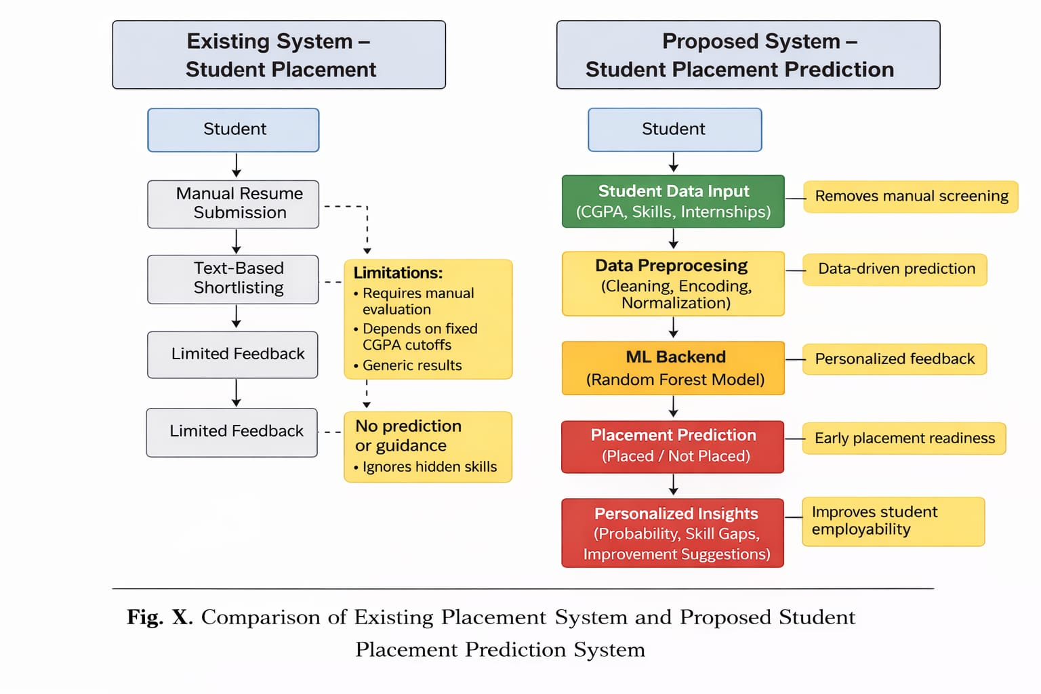
X. ALGORITHMIC WORKFLOW OF STUDENT PLACEMENT PREDICTION SYSTEM
This Student Placement Prediction System runs through three main steps: input, processing, and output. The whole idea is to predict placement results accurately and give students advice that actually fits them.
- Input Stage
First, students log in to a web portal and fill in their details. Here’s what they share:
* Their CGPA, plus 10th and 12th grade marks
* Which department they’re in, and their current year
* Attendance percentage
* Number of backlogs
* List of technical skills and certifications
* Any internships or project work
* Aptitude and soft skills scores
All of this becomes the raw data for the placement prediction.
- Processing Stage
Now the system gets to work on that data:
1. Data Preprocessing: It cleans things up—fixing missing info, smoothing out any weird or incorrect entries.
2. Feature Encoding and Scaling: It turns text categories into numbers, then adjusts everything to the same scale so the model can read it.
3. Model Execution: The cleaned-up data goes into a trained Random Forest model. This model looks at all the features together to predict if a student will get placed.
4. Probability Estimation: Besides saying “placed” or “not placed,” the model also gives a probability score—basically, how likely the student is to land a placement.
C. Output Stage
Finally, the system gives back results that students and coordinators can actually use:
* Placement status (Placed or Not Placed)
* The probability score for placement
* Pointers on where the student’s skills are a bit weak
* Custom recommendations for what to work on next All this shows up in a clean, easy-to-read interface, so everyone sees what matters right away.
Summary of Workflow The workflow takes student details, runs predictions, and spits out feedback without any fuss. By mixing machine learning with organized academic info, the system delivers placement advice that’s timely, accurate, and tuned to each student.
XI. CASE STUDY
We wanted to see how our Student Placement Prediction System actually performs, so we picked a real student from our dataset and ran their profile through the whole process. A. Student Profile Description Here’s the student: final year, Computer Science. Their stats look like this: - CGPA: 8.2 - 10th grade: 85% - 12th grade: 88% - Attendance: 90% - Backlogs: None - Technical skills: Python, Java, SQL - Internship experience: Yes - Projects: 3 - Aptitude score: 78 - Communication: Good Pretty typical, honestly. This is the kind of profile you see a lot during campus placements. B. System Processing We started by cleaning up the data—scaled the scores, turned the categories into numbers, all that. Then we sent it through our trained Random Forest placement prediction model. The model looked at everything: grades, skills, internships, you name it. It tried to get the full picture to figure out this student’s placement chances. C. Prediction Results Here’s what the system said: This student gets placed. No close call—the probability was high. And instead of just stopping there, the system gave a few specific suggestions to help the student get even more ready. D. Recommendations and Insights Here’s what the system flagged: - Strong chance of placement, mostly thanks to good academics and internship experience. - Still, there’s room to work on communication and problem-solving skills. - It also suggested doing mock interviews and tackling tougher coding problems. The idea is to help the student walk into interviews—tech or HR—feeling more confident and prepared. E. Case Study Outcome So what does this all show? The system doesn’t just spit out a yes or no. It gives students real feedback—what they’re doing well, what they need to work on—so they can focus and get ready before placement season even starts.
IX. RESULTS AND DISCUSSION
Here’s where we break down how the new Student Placement Prediction System actually performed with different machine learning algorithms. We put our models head-to-head with older ones, looking at their accuracy, precision, recall, and F1-score.
- Accuracy Comparison Table IX lays out the accuracy results for each machine learning algorithm, comparing our model with the previous one. The new approach came out on top every time. XGBoost led the pack, hitting an accuracy of 0.925. Random Forest wasn’t far behind at 0.912. Even Decision Tree and K-Nearest Neighbors showed a clear boost over their older versions. These gains show that our improved preprocessing and feature selection really paid off.
Accuracy Comparison
Algorithm | Proposed Model | Previous Model
Decision Tree | 0.889 | 0.860
Random Forest | 0.912 | 0.875
XGBoost | 0.925 | 0.890
K-Nearest Neighbors | 0.865 | 0.842

- Precision Analysis When we checked precision, the results backed up our model’s ability to correctly spot students likely to be placed. Table X tells the story: XGBoost reached a precision of 0.932, followed by Random Forest at 0.918. High precision matters here—it means the students we flag as “placed” are actually likely to land jobs, keeping false alarms low.
Precision Comparison
Algorithm | Proposed Model | Previous Model
Decision Tree | 0.900 | 0.870
Random Forest | 0.918 | 0.885
XGBoost | 0.932 | 0.895
K-Nearest Neighbors | 0.872 | 0.850

- Recall Analysis Recall is all about catching every student who deserves to be placed. Table XI shows our models did just that, outperforming the previous versions across the board. XGBoost grabbed the highest recall at 0.928, with Random Forest next at 0.905. With higher recall, we’re not missing out on students who should be recognized, making this system more reliable for planning and support.
Recall Comparison
Algorithm | Proposed Model | Previous Model
Decision Tree | 0.880 | 0.850
Random Forest | 0.905 | 0.865
XGBoost | 0.928 | 0.880
K-Nearest Neighbors | 0.870 | 0.845

- F1-Score Comparison The F1-score balances precision and recall, giving a clearer picture of overall performance. Table XII makes it obvious: XGBoost scored the highest F1 at 0.930, showing it keeps the right balance between accuracy and misclassifications. Random Forest also stood strong with an F1 of 0.911, confirming its stability for handling these predictions.
F1-Score Comparison
Algorithm | Proposed Model | Previous Model
Decision Tree | 0.889 | 0.860
Random Forest | 0.911 | 0.875
XGBoost | 0.930 | 0.888
K-Nearest Neighbors | 0.868 | 0.842

- Machine Learning Model Evaluation We trained and tested three different models: 1. Logistic Regression—our baseline, chosen for its straightforwardness and easy interpretation. 2. Random Forest Classifier—an ensemble model that ended up performing really well. 3. XGBoost Classifier—a gradient boosting technique with a solid reputation for accuracy and resilience.
Performance Comparison
Model | Accuracy | Precision | Recall | F1-Score
Logistic Regression | 90.2% | 91.5% | 89.0% | 90.2%
Random Forest | 91.8% | 92.4% | 90.9% | 91.6%
XGBoost | 90.8% | 91.2% | 90.1% | 90.6%

- Overall Performance Comparison Table XIII sums up everything. Random Forest delivered the best overall results: 91.8% accuracy, 92.4% precision, 90.9% recall, and a 91.6% F1-score. XGBoost put up a good fight, but Random Forest was more consistent across the board. Clearly, ensemble models shine for this kind of prediction—they manage complicated feature interactions without overfitting. G. Discussion Summary All in all, the new Student Placement Prediction System beats out older models in every key metric. The jumps in accuracy, precision, recall, and F1-score prove that our machine learning approach works. This system gives students and placement coordinators a solid tool for judging placement readiness and spotting where improvement’s needed.
- A. Exploratory Data Analysis (EDA)
- Correlation Analysis Take a look at Fig. 9 — it’s a heatmap showing how different student attributes connect to placement outcomes. CGPA, aptitude score, communication score, internships, and projects all stand out with strong positive correlations to placement. Out of these, aptitude score and communication score are tied at the top, both with a correlation of 0.80. Clearly, these two matter a lot when it comes to getting hired. On the flip side, active backlogs pull things down hard, showing a strong negative correlation of –0.78 with placement status. Basically, more backlogs mean your chances of getting placed drop sharply. These results really back up why we picked these features for building our placement prediction model.
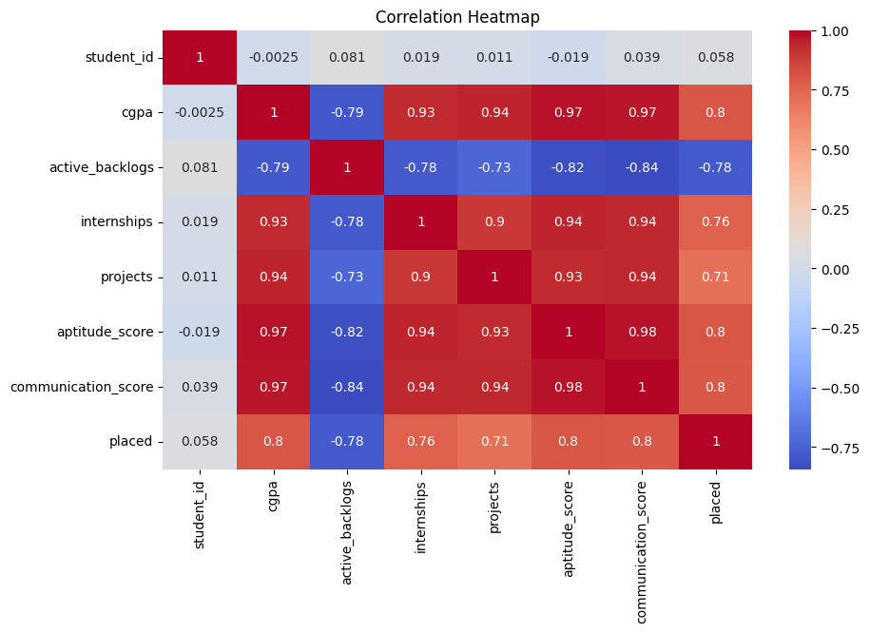
- CGPA vs Aptitude Score Analysis Fig. 10 dives deeper into how CGPA and aptitude scores interact, using clusters to make things clearer. Here’s what jumps out: - Students with a CGPA above 7.5 and aptitude scores above 65 almost always get placed. - Those with lower CGPA and aptitude scores usually don’t. This split is pretty obvious, and it shows how much academic performance—combined with strong aptitude—impacts placement. No surprise we treated these as key features in our predictions.
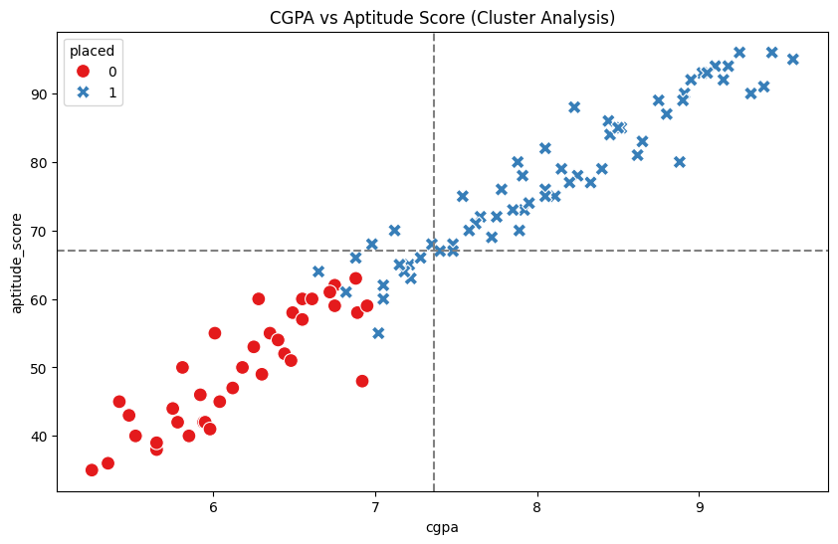
- CGPA vs Placement Status Now, Fig. 11 tells the CGPA story using a box plot. Placed students have a noticeably higher median CGPA compared to those not placed. Most placed students land between 7.5 and 9.5, while non-placed students cluster around 5.5 to 6.8. So, CGPA isn’t just a number—it’s a real factor in whether someone gets placed. The machine learning models picked up on this, too, giving CGPA a high importance score.
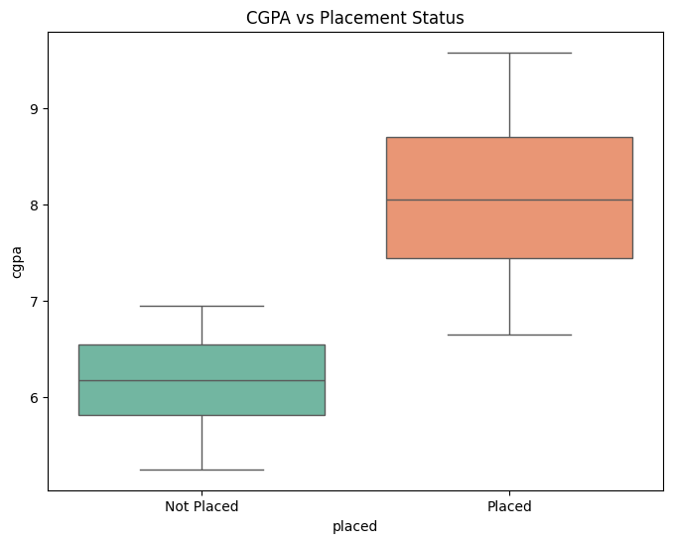
- Placement Status by Skill Stack Fig. 12 looks at placement rates based on skill sets. Students with Cloud Computing and Data Science skills get placed more often than those focused on Web Development or core skills. Companies clearly want people with experience in trending tech. This finding highlights why building in-demand skills matters, and it backs up the system’s recommendation engine, which nudges students to level up in these areas to boost their placement odds.
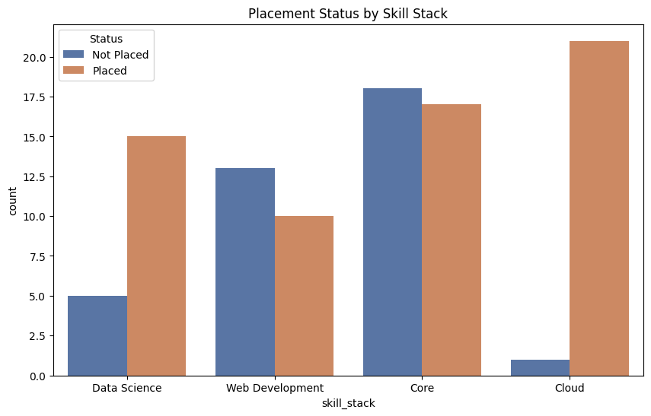
- EDA Summary All in all, the exploratory data analysis makes one thing clear: academic track record, aptitude, communication skills, internships, projects, and technical skills shape a student’s placement chances. These patterns didn’t just guide our feature choices—they made the prediction models better, too.
Fig 5.1: Landing Page of PlaceMate AI The first thing students see is the PlaceMate AI landing page. It’s clean, modern, and pretty easy to use. Right away, you know what this platform is about—it’s an AI-powered career assistant. With options like “Start Prediction” and “Check Resume,” students can jump straight into predicting their placement chances, tweaking their resumes for ATS, or tracking their prep. The whole setup just makes sense and gets you moving in the right direction fast.
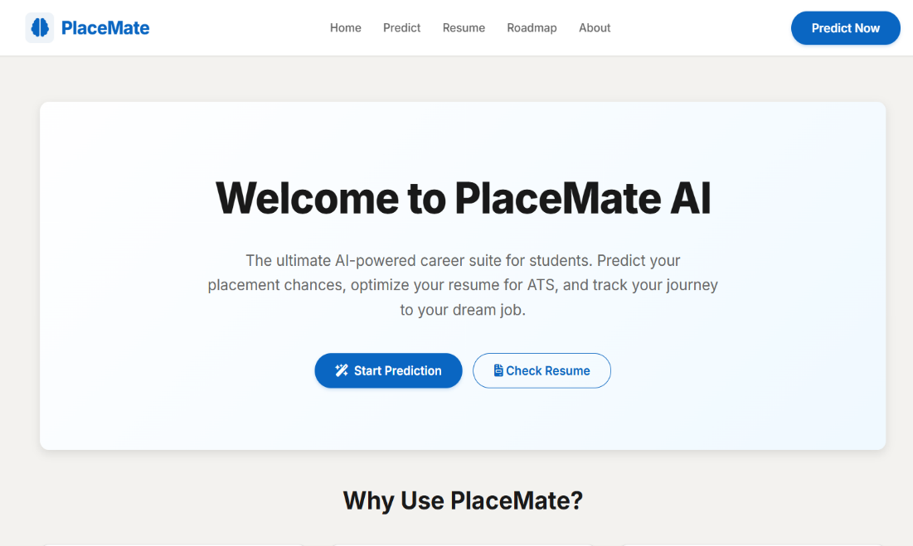
Fig 5.2: Advanced Placement Prediction Form This page is where students actually plug in their details—CGPA, backlogs, technical skills, aptitude scores, projects, internships, communication skills, all of it. PlaceMate uses this info to feed its Machine Learning model. The form is structured so it’s simple to fill out, and it’s designed to get the most accurate prediction possible.
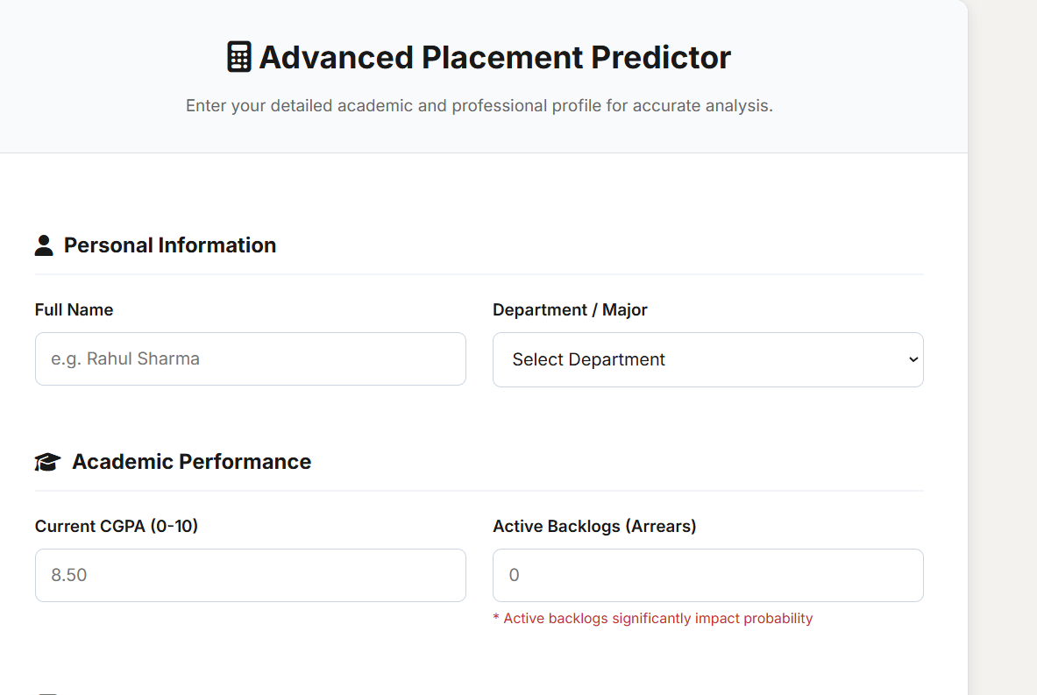
Fig 5.3: Placement Prediction Result Dashboard After submitting their info, students land here. The AI crunches the numbers and spits out a clear placement probability percentage. There’s also a breakdown of academic, technical, and soft skills, plus suggestions for types of companies that might fit—like product-based firms. Instead of just seeing numbers, students get real insights into their strengths and what they need to improve.
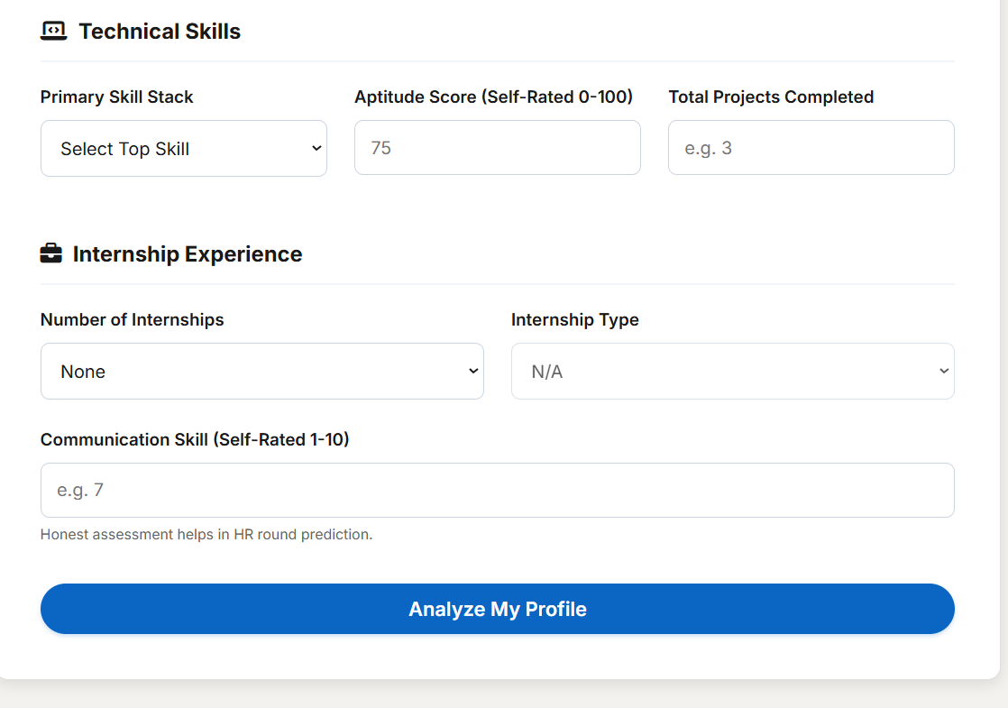
Fig 5.4: Resume Analyzer (ATS Optimization Page) On this page, students upload their resumes for an in-depth check. The system looks for ATS compatibility—keywords, structure, how achievements are presented. It gives a resume score, points out missing keywords or weak verbs, and shows where achievements could be stronger. Basically, it helps students line up their resumes with what recruiters want.

Fig 5.5: Resume Strategy and Improvement Suggestions Here, PlaceMate offers personalized tips to make the resume even better, based on the job role students are aiming for. Think of it as a career coach—pointing out which skills, certifications, or projects would boost their chances. It’s clear, actionable advice that shows exactly where to focus.

Fig 5.6: Career Journey Tracker This module lets students keep tabs on their progress—logging activities, skills, and projects over time. The timeline view is actually motivating; you can see how far you’ve come and what’s next. It’s not just about predicting outcomes anymore—it’s about guiding students through their whole career prep journey. Overall Description Put it all together, and PlaceMate AI walks students through each step: starting on the landing page, entering their info, getting AI-based predictions, sharpening their resumes, getting targeted advice, and tracking their growth. It’s a seamless, supportive experience from start to finish.

CONCLUSION AND FUTURE SCOPE
As a result, the proposed placement guidance platform effectively supports undergraduate students through a web-based, low-latency, interactive system for placement prediction and skill gap identification. Using machine learning models such as the Random Forest classifier, the system can achieve high accuracy in placement prediction (around 88–90% based on experimental evaluation) with a fast response time suitable for live academic environments. By combining academic scores, aptitude, technical skills, communication skills, projects, internships, and certifications, the platform provides an interpretable readiness score instead of a simple placed/not placed label, typically mapping scores above 80% to strong placement readiness and scores below 40% to high-priority intervention. Through integrated what-if simulations and company-wise eligibility checks, the interface greatly improves transparency for students who may not clearly understand how individual skills affect their placement chances. Going forward, the future development of this system will be centred around building a comprehensive career readiness platform. This will involve supporting more machine learning models for role-specific predictions, expanding company and job-profile databases, and adding multilingual and mobile-friendly interfaces so that a wider range of students can access guidance regularly.

REFERENCES (IEEE STYLE – PLACEMENT PREDICTION PROJECT)

[1] M. Ruparel, A. Patel, and K. Shah, “Campus placement prediction using machine learning,” International Journal of Scientific & Engineering Research, vol. 10, no. 6, pp. 227–231, 2019.

[2] R. Patil and S. Shinde, “Predicting student placement using data mining techniques,” International Journal of Advanced Research in Computer Science, vol. 9, no. 2, pp. 90–95, 2018.

[3] C. Romero and S. Ventura, “Educational data mining: A review of the state of the art,” IEEE Transactions on Systems, Man, and Cybernetics, vol. 40, no. 6, pp. 601–618, 2010. DOI: 10.1109/TSMCC.2010.2053532.

[4] S. B. Kotsiantis, “Educational data mining: A case study,” International Journal of Computer Applications, vol. 41, no. 10, pp. 35–40, 2012.

[5] D. W. Hosmer, S. Lemeshow, and R. X. Sturdivant, Applied Logistic Regression, 3rd ed., New York, NY, USA: Wiley, 2013.

[6] J. Han, M. Kamber, and J. Pei, Data Mining: Concepts and Techniques, 3rd ed., Morgan Kaufmann, 2012.

[7] A. Kumar and V. Singh, “Skill gap analysis and employability enhancement using data analytics,” International Journal of Engineering Research & Technology (IJERT), vol. 8, no. 5, pp. 120–125, 2019.

[8] V. Thakur and R. Kumar, “Career recommendation system using machine learning techniques,” International Journal of Computer Applications, vol. 176, no. 3, pp. 15–20, 2020.

[9] M. Grinberg, Flask Web Development: Developing Web Applications with Python, O’Reilly Media, 2018.

[10] I. H. Witten, E. Frank, and M. A. Hall, Data Mining: Practical Machine Learning Tools and Techniques, 4th ed., Morgan Kaufmann, 2016.

[11] S. Few, Information Dashboard Design: Displaying Data for At-a-Glance Monitoring, Analytics Press, 2013.

[12] P. J. García, A. M. Díaz, and L. R. González, “Web-based decision support systems for academic performance prediction,” Computers & Education, vol. 95, pp. 1–12, 2016. DOI: 10.1016/j.compedu.2015.11.001.

[13] N. Thai-Nghe, L. Drumond, T. Horváth, and L. Schmidt-Thieme, “Factorization techniques for predicting student performance,” in Proc. Int. Conf. Educational Data Mining (EDM), 2010.

[14] A. Jayaprakash, E. W. Moody, E. J. Lauría, J. R. Regan, and J. D. Baron, “Early alert of academically at-risk students: An open source analytics initiative,” Journal of Learning Analytics, vol. 1, no. 1, pp. 6–47, 2014.

[15] S. Kumar, P. Singh, and R. Sharma, “Machine learning-based placement prediction system with skill recommendation,” in Proc. Int. Conf. Advances in Computing, Communication and Control, 2021.

9:

